Part 2 – Speedy Editing

Note: The changes from Word 97 to Word 2003, with regard to the editing techniques presented in this section, are so subtle that all versions are represented in this section. Where relevant, some distinctions are made.

AutoCorrect

AutoCorrect may be one of the biggest time-savers Word offers. Many of the AutoCorrect features occur “behind the scenes.” For example, if you type the word definite the way it’s usually misspelled: defi(nate), Word will automatically make the correction. To see the many corrections Word makes automatically, select Tools, AutoCorrect and scroll down the list.

Practice:

- Select Tools, AutoCorrect.

- In the beginning of the dialog box look at some of the corrections Word makes automatically (e.g., capitalizing the first letter of sentences, correcting your mistake if you accidentally type a word with two capital letters rather than one, etc.).

- Just for fun try some of the built-in formats. For example if you type a “:” followed by a right parenthesis “)” you will get a “smiley face”: ☺

- Note the many commonly misspelled words that are also corrected automatically.

Customizing AutoCorrect:

More importantly, you can make your own AutoCorrect entries. When you make an AutoCorrect entry, keep the following points in mind:

- Do not use an existing word. AutoCorrect will exchange your entry with the replacement you’ve chosen as soon as you press the spacebar. Consequently, if you wanted to have the name “Alfred Nolan Doyne” be entered every time you typed “a-n-d” that is what would happen (including all the times you just meant the word and). You could correct this problem by adding a number, e.g., and2, so that the full name wasn’t entered every time you typed and.

- Try to make your entry logical so that you can remember it.

- While AutoCorrect may be used for long names (e.g., company names, names of people, long words, etc.), it may also be used for words that are difficult to format. For example, I type the word résumé often and putting in the accent marks over the two e’s is time-consuming. Consequently I made the AutoCorrect entry res so that every time I typed res the word résumé would appear.

The AutoCorrect Dialog Box
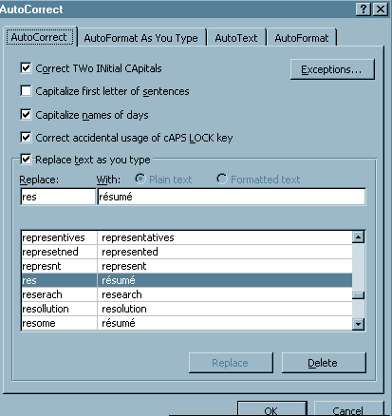

Type your entry and the word you want to replace it with here.

If you ever need to delete an entry (such as when one of my children had my son Aaron’s name automatically be replaced with “Jerkhead”), just highlight the selection and press Delete!

Tip: In the AutoCorrect window above, note that I’ve deselected “Capitalize first letter of sentences” because that particular correction is often more intrusive than you might want. For example, if you’re creating a bulleted list you might not want the first letter of each bulleted item capitalized; however, Word will interpret each bulleted item as a new sentence. If you find yourself undoing this correction repeatedly, deselect the option in AutoCorrect.

Practice:

- Open up a new document.
- Select Tools, AutoCorrect.
- Type the initials of your name (as long as they don’t spell an actual word).
- In the “Replace with:” box, make sure to type your name exactly as you want it to appear (with capital letters or a title).
- Make sure to click Add and OK.
- Type your initials and press space; your name should appear as you formatted it.

Find and Replace

One of the most powerful uses of Find and Replace is as an editing tool. For example, if you had a long text and wanted to just replace the occurrences of a particular font style used intermittently throughout the document, it could take a long time. By using Find and Replace, you can locate all of the instances of a particular font, style, formatting option, tab, special character, etc., and make your changes in seconds.

- Open up the Find and Replace document (or, simply use a document that contains a lot of formatting options). Notice all the occurrences of italics. Make sure your insertion point is in the Find box.

- Select Edit, Find (make sure you have the dialog box fully open, i.e., click on More) and click on Format.

- When the Format menu opens, select Font.

- In the Font dialog box click on "Italic" under Font Style since that is what you want to find.

- Close the font box, and make sure your insertion point is now in the Replace With: box.

- Again click on Format and then Font and this time choose "Not Italic" from the Font Style list.

- After closing the font box, click on Replace All. You should see every instance of italics replaced with regular text.

Further Practice

Note: If your last find and replace options still appear, make sure to click "No Formatting" in the find and replace box to remove the previous search options.

- Open up the Find and Replace exercise again. This time you will find occurrences of underlined words and replace them with italics with no underlining. Book titles and words that are emphasized are now more commonly italicized than underlined.

- Choose Edit, Replace. Again make sure the box is fully open and that your cursor is located in the Find What box.

- Click on Format and then Font. Click on the drop-down menu for Underlining and select "Single."

- Make sure your cursor is located in the Replace with box. Again choose Format and Font. In the Font Style box choose "Italics.” In the Underline drop-down menu, choose "None."

- Click on "Replace All." Every instance of underlining will now be replaced with text that is in italics and not underlined. If this were a long document with many occurrences of underlined book titles or emphasized words, you can imagine how much time the Find and Replace function just saved.

Tip: The find and replace feature can make many other editing changes rapidly. For example, a text containing older hyphens (- -) or hyphens incorrectly used as dashes can quickly be updated with em dashes ( — ), the longer dashes used in professional documents, by typing in the older hyphens in the Find box and selecting em dashes from the Special Characters list and entering it into the Replace With box. Check the various options in the Find and Replace dialog box. Find and Replace is an underused option that can save a great deal of time when editing documents.

The Find and Replace box pictured below is from Word 2003; its features are nearly identical to previous versions of Word. If you click on the Special button (to access special characters or special formatting options) at the bottom of the Find and Replace window, you’ll note there are a few more options.

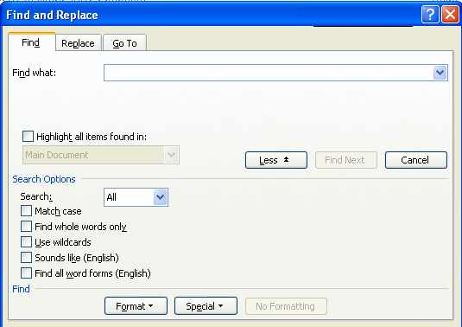

Tools: Spell Check, Grammar Check, Readability Statistics, and the Thesaurus

Spelling and Grammar Check

There are two rules for using Word’s (or any other word processing program’s) spell and grammar check:

Always use them.
Never trust them.

Spell check is only as good as the user. If you don’t know what spelling of a word to choose, spell check is pretty useless (as the following poem dramatizes):

I have a spelling checker.
It cam with my PC;
It plainly marks four my revue
Mistakes I can not sea.
I’ve run this poem threw it,
I’m sure your please too no,
Its letter perfect in it’s weigh,
My checker tolled me sew.

Nevertheless the spell check should always be used. No matter how many times a writer proofreads his or her document, misspelled (and often miss-typed) words can remain undetected. To spell check a document, select Tools, Spelling and Grammar or click on the spell check toolbutton (pictured left).

Customizing Spell Check’s Dictionary

If there are words you use commonly such as a medical word like arrhythmia that are not in Word’s dictionary, first make sure the word is spelled correctly and then add it to the dictionary so that it will only be underlined when you type it incorrectly. In the example below the word Pyrus is highlighted, not because it’s misspelled, but because it’s not part of Word’s dictionary. Rather than clicking “Ignore,” click “Add” or “Learn” so that the word will not be checked in the future unless you’ve spelled it incorrectly. Typically, you’d only add words to the dictionary that you use frequently.

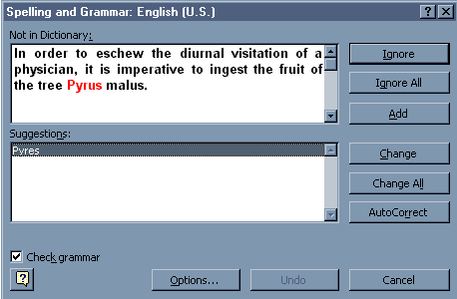
By selecting “Add” the word will become part of Word’s dictionary.

Grammar Check

Grammar check requires even more knowledge on the part of its user. Although grammar check often will be right, it may suggest corrections such as a capital letter (when the program thinks you are at the beginning of a line) that are incorrect. Nevertheless, grammar check should be used every time you finish a document; it will often "catch" mistakes you have missed.

Customizing Grammar Check

By default grammar check is set for standard usage. If, however, you are creating technical documents or other papers that require a different level of usage, change the writing style “level” to one that fits your writing. To change the default, select Tools, Spelling and Grammar and then click on the Options button in the dialog box that appears.

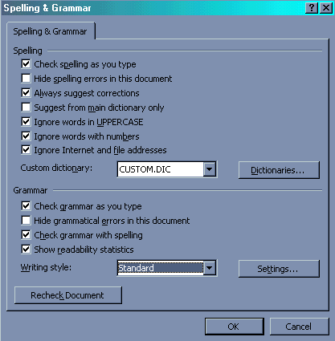

Check the appropriate writing style (level of usage such as technical, formal, casual) to fit your document.

Note the options under Grammar. To see a document’s Readability statistics, check the box more on Readability on page 26.

Note for Word 2002 and 2003 Users: Beginning with Word 2002, the five writing style categories (e.g., formal, standard, technical, etc.) described and shown above are eliminated. However, in lieu of the writing style categories, Word 2002/2003 offers a customized list of Style options that may be checked along with Grammar. If you select “Grammar Only” from the drop down menu the basic grammar mistakes will be checked. If you select “Grammar and Style” stylistic options (such as the use of clichés, wordiness, gender-specific pronouns, etc.) will be checked as well. You may also customize the Style check options by selecting the items you want checked from the Style menu (see below).

Spelling and Grammar window (from Word 2003) – To customize Grammar Options, click on the Options button at the bottom of the window:

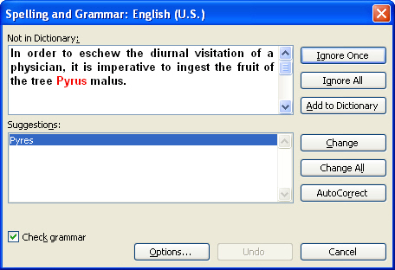

Spelling and Grammar Options window (from Word 2003) – Note the drop-down menu in the lower right hand area. You may select Grammar Only or Grammar and Style. To customize, choose the Settings button:

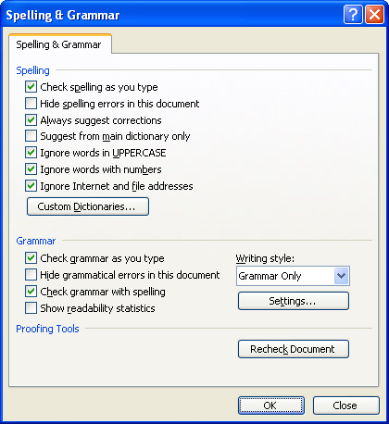
Writing style drop-down menu
Settings button

Grammar Settings Window (from Word 2003) –

Readability Statistics

Grammar Settings window (from Word 2003) – Note that in the Grammar Settings window, you may select “Grammar Only” or “Grammar and Style” from the drop-down menu at the topc of the window. If you select “Grammar and Style,” ALL the style options will be selected. To customize, select “Grammar Only,” and then choose the specific Style options you’d like checked.

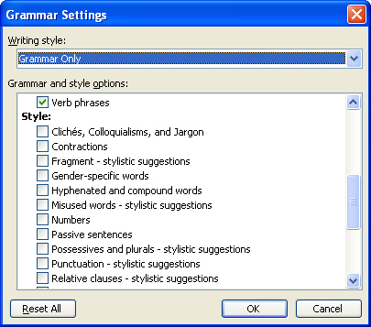
Choosing specific Style options allows you to select only the areas you need checked.

Readability Statistics:

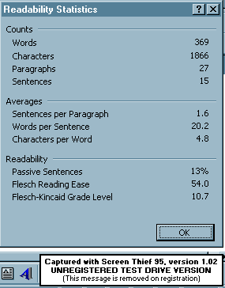
Total number of words, sentences, etc.
Average number of sentences, words per sentence, and characters per word.
Provides information on a document’s readability and/or ease of reading.

In the spelling and grammar options’ box original pictured on page 24, notice also the option to "Show readability statistics." By default, this option is not selected. If it is checked, you will get the readability and statistical breakdown (pictured on page 26) on your document when you have completed the spelling and grammar check. This breakdown offers information that may be very valuable to a writer. For example, if a writer tends to write short, choppy sentences (or long, wordy sentences) he/she can see the average number of words per sentence in his/her document. Similarly, a writer who uses too many passive constructions can check the percentage of passive sentences in the document.

The Thesaurus

For Word 97/2000 Users:

The thesaurus also needs to be used with discretion or you might wind up creating a sentence like this:

In order to eschew the diurnal visitation of a physician, it is imperative to ingest the fruit of the tree Pyrus malus. [An apple a day keeps the doctor away.]

Nevertheless, the thesaurus can help cut down on word repetition and often can provide the right word rather than the almost right word. The thesaurus also provides a look-up function and specifies whether a word is a noun, verb, adjective, etc. Point out to students that if they are looking for a synonym for an adjective they should make sure the word suggested in the thesaurus is also an adjective. To use the thesaurus first select the word you’d like to replace and then select Tools, Language, Thesaurus.

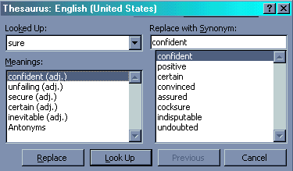

Thesaurus Dialog Box

For Word 2002/2003 Users:

The Thesaurus set up is quite a bit different in later versions of Word. Rather than a pop-up window, the Thesaurus option appears as a panel on the right hand side of your workspace.

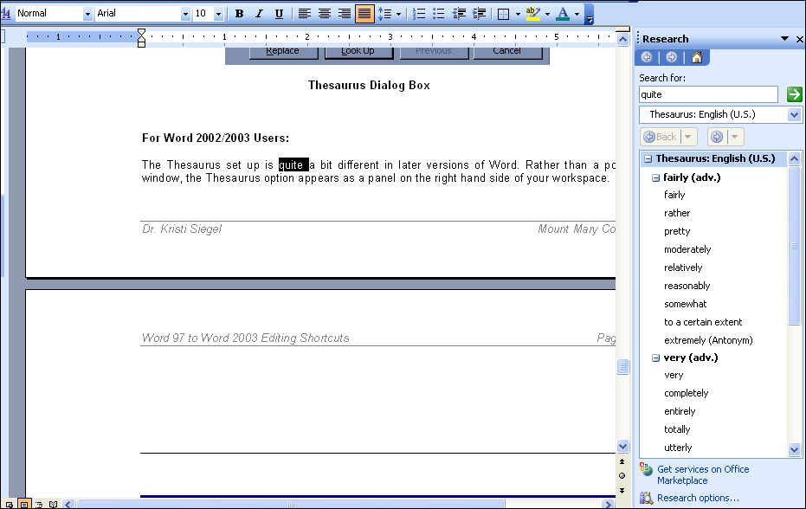

Thesaurus panel (from Word 2003) – By clicking on any of the synonyms suggested for the word quite (in the right-hand panel), a drop-down menu will appear so that you can choose to select the word, copy the word, or look up the word to find more synonyms.

Handy Keyboard Shortcuts

Word 97–2003 Keyboard Shortcuts for Editing Documents

Know the shortcuts for cutting, copying, and pasting text (or graphics). Tool buttons aren’t always available:

Select text first and then:

- Press Control + C – to copy text
- Press Control + X – to cut text
- Press Control + V – to insert text

Also:
Use Control + A to select ALL the text (graphics) in an entire document.

General Editing Commands:

Select the paragraph or click anywhere within a paragraph, and then:

To align paragraphs:

- Press Control + E – to center paragraph (or line)
- Press Control + J – to justify paragraph
- Press Control + L – to left align paragraph to the left (this is Word’s default paragraph alignment)
- Press Control + R – to right align paragraph

To change line spacing (select text first!):

- Press Control + 1 – to single-space text
- Press Control + 2 – to double-space text
- Press Control + 5 – to set 1.5 line spacing

Whoops! I just typed three lines with the CAPS button on; how can I change the text case without re-typing?

Select the text and then select Format, Change Case – you may choose from the following options:

- Sentence case.
- lowercase
- UPPERCASE
- Title Case
- tOGGLE cASE

